**SSS CONTRIBUTION TABLE 2019**

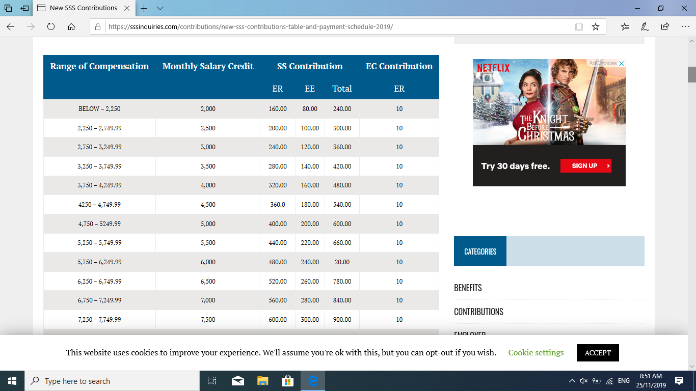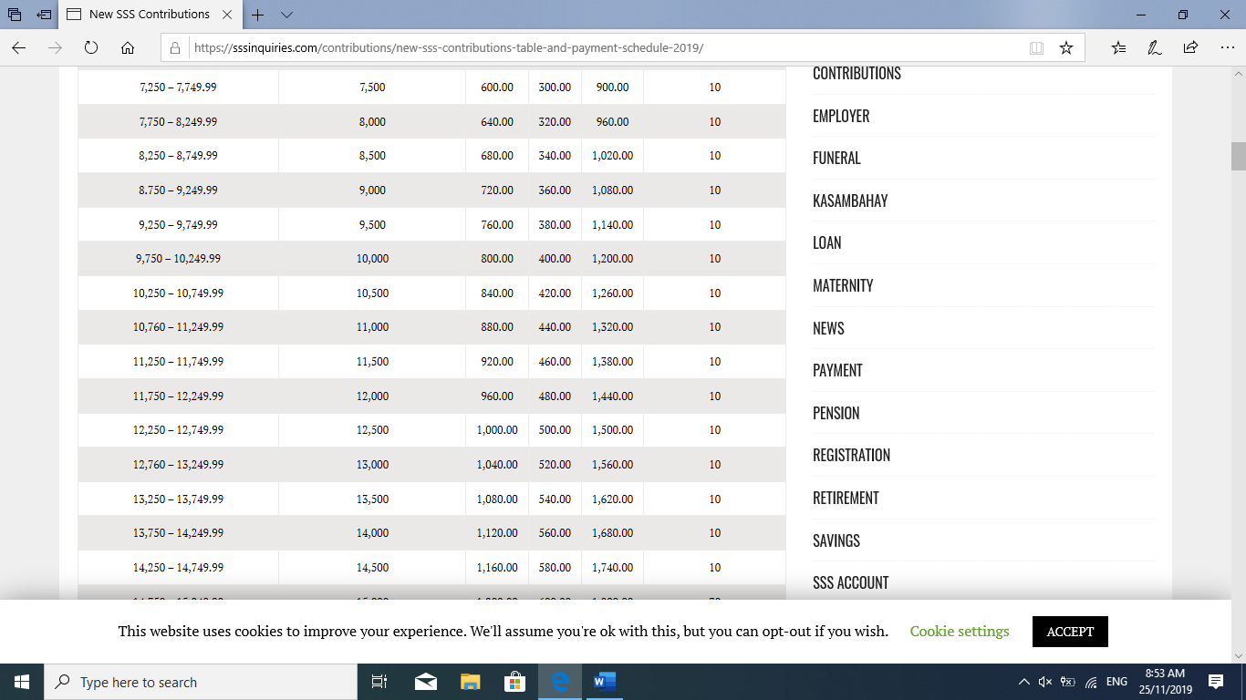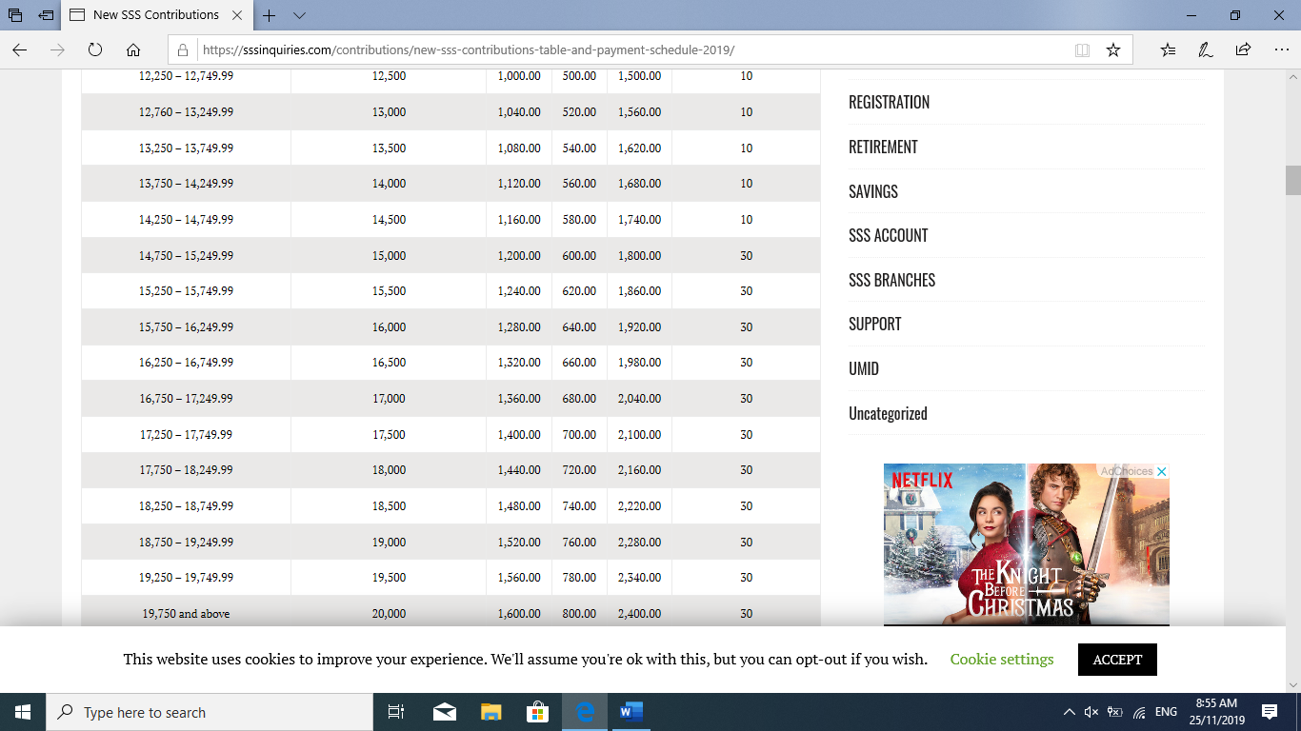

**PHILHEALTH CONTRIBUTION TABLE**

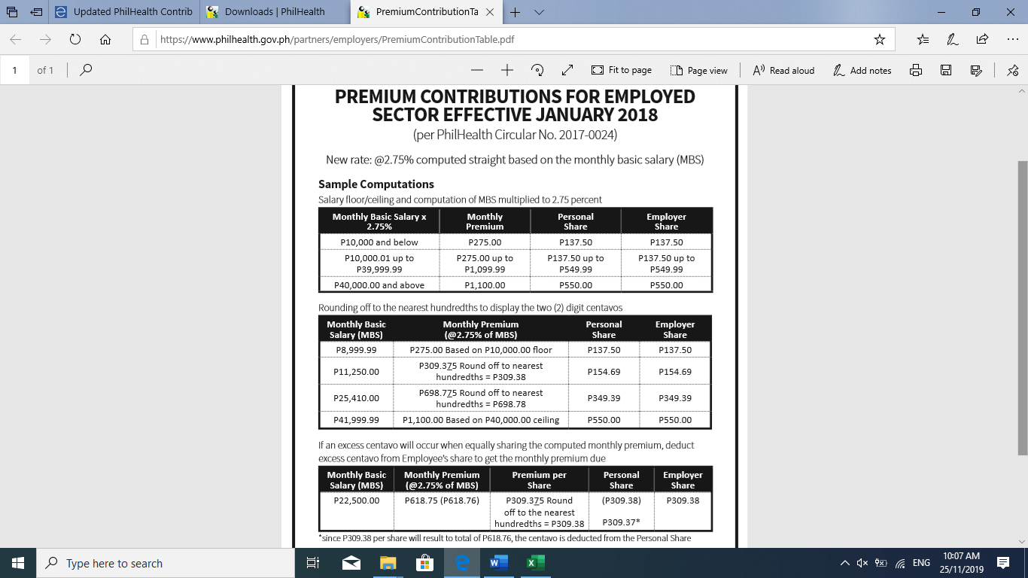

**PAG IBIG CONTRIBUTION TABLE**

**(Employees have the option to increase his/her contribution and employer may pay the same amount of contribution the employee pays at their discretion)**

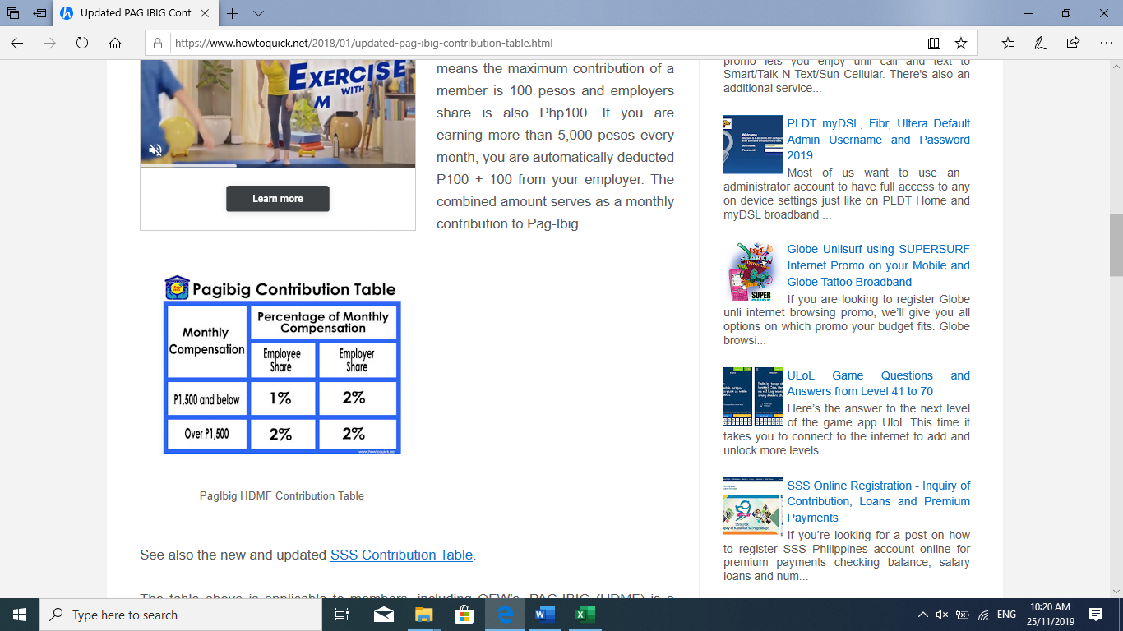

**BIR WITHHOLDING TAX TABLE**



**BIR ANNUAL INCOME TAX TABLE**